P. Lakshmivani vani
192365018
CSA1013

CO3 ASSESSMENT TOOL 2 – CODE REVIEW & REPOSITORY EVALUATION
Smart Cold Storage Monitoring and Food Preservation System
Course Code | CSA10 | Course Title | Software Engineering
CO Assessed | CO3 | Assessment | Assessment Tool 2 – Code Review & Repository Evaluation
Weightage | 20% | Total Marks | 25
Student Name | P. Lakshmivani | Reg. No. | 192365018_
ASSESSMENT QUESTION
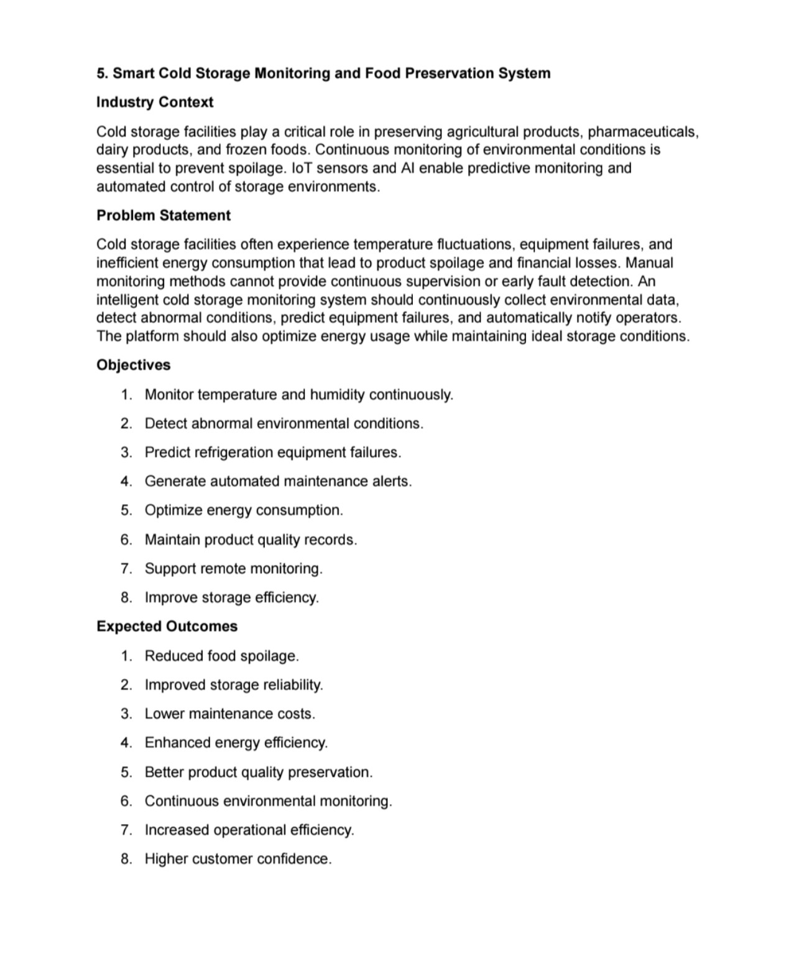

1. Problem Overview
1.1 Assigned Problem Statement
The assigned problem is a Smart Cold Storage Monitoring and Food Preservation System. Cold storage facilities are important for preserving agricultural products, pharmaceuticals, dairy products and frozen foods. The problem statement highlights temperature fluctuations, equipment failures and inefficient energy consumption as major causes of product spoilage and financial loss.
Manual monitoring cannot provide continuous supervision or early fault detection. Therefore, the proposed system continuously collects environmental data, identifies abnormal conditions, predicts refrigeration equipment failures, generates maintenance alerts and supports energy-efficient operation while maintaining suitable storage conditions.
1.2 Proposed Solution Summary
The proposed solution combines IoT sensing, a communication layer, a data storage layer, monitoring software and an analytics layer. Temperature and humidity sensors periodically collect readings from the cold-storage environment. A controller or edge device transmits these readings to a server or cloud database. The monitoring application displays the current condition, stores historical records and raises alerts when values cross configured limits.
An analytics component can examine historical temperature, humidity, compressor or energy-related readings to identify unusual patterns. A predictive-maintenance model can be introduced after sufficient historical data has been collected. This creates a progression from simple threshold-based monitoring to data-driven predictive monitoring.
1.3 Objectives
• Monitor temperature and humidity continuously.
• Detect abnormal environmental conditions at an early stage.
• Predict refrigeration equipment failures using historical operating data.
• Generate automated maintenance alerts.
• Optimize energy consumption while maintaining required storage conditions.
• Maintain product-quality and environmental records.
• Support remote monitoring by authorized operators.
• Improve overall storage efficiency and reliability.
1.4 Key Functionalities
The key functionalities are sensor-based data acquisition, real-time condition monitoring, abnormal-condition detection, historical data logging, predictive maintenance support, automated notifications, energy monitoring, product-quality records and remote access.

2. System Requirements and Architecture
2.1 Functional Requirements
ID | Requirement | Description
FR1 | Sensor Monitoring | Collect temperature and humidity readings at regular intervals.
FR2 | Data Storage | Store timestamped environmental and equipment readings for analysis.
FR3 | Threshold Detection | Compare readings with configured safe operating ranges.
FR4 | Alert Generation | Notify operators when abnormal conditions are detected.
FR5 | Equipment Monitoring | Track refrigeration-related indicators and identify possible failures.
FR6 | Predictive Analysis | Use historical data to estimate equipment-failure risk.
FR7 | Energy Monitoring | Record energy-related information and identify inefficient operation.
FR8 | Remote Dashboard | Allow authorized users to view current and historical status remotely.
2.2 Non-Functional Requirements
• Reliability: the monitoring process should operate continuously and tolerate temporary communication failures.
• Scalability: the design should support additional storage rooms and sensors without major restructuring.
• Security: only authorized operators should access monitoring and administrative functions.
• Maintainability: sensor, database, analytics and dashboard components should remain modular.
• Usability: abnormal conditions should be easy to understand through clear status indicators and alerts.
• Performance: recent readings and critical alerts should be available with minimal delay.
2.3 High-Level Architecture
A suitable layered architecture is: Sensor Layer → Edge/Communication Layer → Backend/API Layer → Database → Analytics/Alert Layer → Web/Mobile Dashboard. This separation allows each component to be tested independently and makes future replacement of a sensor, database or analytics method easier.
Architecture justification: IoT sensing is isolated from application logic; APIs provide a controlled interface to stored data; the database preserves historical records; analytics processes historical patterns; and the dashboard provides human-readable information. This modular organization supports maintainability and collaborative development.

3. Repository Organization
3.1 Recommended Repository Structure
For the assigned system, the following repository structure provides a clear separation of concerns. It is a recommended organization for the implementation and can be adjusted to match the student's actual Git repository.
Folder / File | Purpose
cold-storage-monitoring/ | Root project directory
├── docs/ | Problem statement, architecture, API and user documentation
├── firmware/ | Sensor/controller source code
├── backend/ | Server/API and business logic
├── database/ | Schema, seed data and migration scripts
├── analytics/ | Anomaly detection and predictive-maintenance models
├── dashboard/ | Web or mobile monitoring interface
├── tests/ | Unit, integration and validation tests
├── screenshots/ | Evidence for assessment and demonstrations
├── .gitignore | Files and folders excluded from version control
├── README.md | Installation, usage and project overview
└── requirements.txt / package files | Software dependencies
3.2 Naming Conventions
• Use descriptive lowercase folder names such as firmware, backend and analytics.
• Use meaningful file names such as sensor_service.py, alert_controller.py and database.sql.
• Use consistent naming within each programming language.
• Avoid names such as final.py, testnew.py or temp1 unless they have a clear purpose.
• Keep configuration and secrets outside source control and provide safe example configuration files.
3.3 Maintainability and Collaboration
A structured repository reduces the time required to locate files and understand dependencies. Separate folders prevent unrelated code from becoming mixed together. Documentation and tests placed alongside the project make onboarding easier. The structure also allows different team members to work on firmware, backend, analytics and interface components with fewer conflicts.

4. Code Quality Review
4.1 Readability
Code for an IoT monitoring system should be readable because failures may need to be diagnosed quickly. Functions should perform one clear task, variable names should describe their meaning, and repeated logic should be avoided. Comments should explain important decisions rather than restating obvious code.
4.2 Modularity
The system should separate sensor acquisition, validation, communication, storage, alert generation and analytics. For example, a sensor-reading module should not contain database queries or dashboard-specific code. This reduces coupling and allows each component to be tested independently.
4.3 Coding Standards
• Follow the standard style guide of the selected programming language.
• Use consistent indentation and naming conventions.
• Validate sensor values before storing or processing them.
• Handle communication and database errors without terminating the entire monitoring process.
• Use configuration files or environment variables for thresholds, database settings and credentials.
• Avoid hard-coded credentials and sensitive keys.
4.4 Documentation in Source Code
Important modules should include short documentation describing their purpose, inputs, outputs and error conditions. Public API endpoints should specify request parameters and response formats. The predictive-maintenance component should document its input features, training process, output meaning and validation method.
4.5 Strengths
• Clear separation between environmental monitoring and higher-level application functions.
• Historical data creates a basis for trend analysis and predictive maintenance.
• Automated alerts reduce dependence on manual observation.
• A dashboard supports remote monitoring and faster operator response.
4.6 Areas for Improvement
• Add automated unit and integration tests for critical components.
• Improve error logging with timestamps and severity levels.
• Add configuration validation before the application starts.
• Document API endpoints and sensor communication formats.
• Add code-quality checks to the version-control workflow.

5. Version Control Evaluation
5.1 Git Repository Evaluation
The assessment document asks for review of commit history, branching strategy, commit messages and repository maintenance. For the cold-storage system, Git should be used as the central history of source-code changes. The exact student commit history is not included in the supplied problem statement, so the following is the recommended evaluation standard rather than a claim about an unseen repository.
5.2 Commit History
Commits should represent small, meaningful changes. Examples include: 'Add DHT sensor reading module', 'Create environmental readings table', 'Implement abnormal-temperature alert', and 'Add dashboard status cards'. Such messages make it easier to understand why the code changed and to identify the source of regressions.
5.3 Branching Strategy
A simple collaborative strategy can use main for stable code and short-lived feature branches such as feature/sensor-monitoring, feature/alerts and feature/dashboard. Changes should be reviewed before merging into main. This approach reduces accidental disruption to the stable version.
5.4 Repository Maintenance
• Maintain a useful README and keep it synchronized with the current implementation.
• Exclude build files, local configuration and secrets through .gitignore.
• Use pull requests or equivalent review practices for team changes.
• Tag stable releases where appropriate.
• Remove obsolete files and abandoned experimental code.
5.5 How Version Control Supports Collaboration
Version control allows multiple developers to work on different components, compare changes, recover earlier versions and review modifications. For this system, one member could work on firmware while another works on the dashboard and another on analytics. Git provides a common history and reduces the risk of losing work.

6. Code Testing and Validation
6.1 Testing Strategy
Testing should cover sensor input, data validation, storage, alerts, API behavior, dashboard display and predictive-analysis outputs. Testing should be performed using both normal and abnormal environmental values because the central purpose of the system is early detection of unsafe conditions.
Test ID | Test Scenario | Input / Action | Expected Result
TC01 | Normal temperature | Provide a reading within configured safe range. | System accepts reading and displays normal status.
TC02 | High temperature | Provide a reading above the configured limit. | Abnormal status and operator alert are generated.
TC03 | Low temperature | Provide a reading below the configured limit. | Low-temperature warning is generated.
TC04 | High humidity | Provide humidity above the allowed range. | Humidity warning is displayed and logged.
TC05 | Sensor failure | Simulate missing/invalid sensor value. | Error is logged and invalid value is not treated as normal.
TC06 | Database failure | Temporarily make storage unavailable. | Application logs the error and continues/retries safely.
TC07 | Remote dashboard | Open dashboard and request latest readings. | Latest available status is displayed.
TC08 | Alert recovery | Return an abnormal value to normal range. | System records recovery and clears active warning appropriately.
6.2 Validation Approach
Validation should confirm that recorded readings match the sensor source, timestamps are correct, alerts are produced for abnormal values, and the dashboard reflects the stored status. Where predictive models are used, validation should use a separate evaluation dataset and appropriate performance measures rather than relying only on training accuracy.
6.3 Evidence to Attach
• Screenshot of the application dashboard showing normal environmental values.
• Screenshot showing a high-temperature or high-humidity alert.
• Screenshot of stored readings in the database.
• Screenshot of test execution results.
• Screenshot of the Git repository test folder or automated test workflow.

7. Repository Documentation
7.1 README Requirements
The README should provide enough information for another student or evaluator to understand and run the project. It should begin with the project title, problem statement and a short description of the solution.
• Project overview and objectives.
• System architecture and component description.
• Hardware and software requirements.
• Installation and setup instructions.
• Database configuration and schema information.
• How to start the backend and dashboard.
• How to configure sensors and environmental thresholds.
• API documentation or endpoint summary.
• Testing instructions.
• Screenshots and expected output.
• Known limitations and future enhancements.
7.2 Installation Guide – Recommended Sequence
1. Install the required development tools and programming-language dependencies.
2. Clone the repository and enter the project directory.
3. Configure the database and execute the schema/migration scripts.
4. Configure sensor/controller communication parameters.
5. Set environment variables for application configuration.
6. Install backend and analytics dependencies.
7. Start the backend/API service.
8. Start the dashboard or monitoring application.
9. Verify sensor readings and run the provided test cases.
7.3 Usability and Maintainability Improvements
Documentation can be improved by adding diagrams, troubleshooting steps, sample configuration files, API examples, screenshots and a clear list of known limitations. A versioned changelog can also help users understand changes between releases.

8. Code Review Findings and Recommendations
8.1 Overall Findings
The proposed cold-storage monitoring system has a strong application focus because it connects continuous sensing with operational decisions. The main value is not only collecting temperature and humidity data but converting those readings into timely alerts, historical records, maintenance insights and energy-efficiency actions.
Review Area | Assessment | Observation
Problem relevance | High | The system directly addresses spoilage, equipment reliability and operational monitoring.
Modularity | Good | Separate sensing, backend, database, analytics and dashboard components support maintainability.
Automation | High | Threshold alerts reduce dependence on manual monitoring.
Predictive capability | Future enhancement | A reliable model requires sufficient historical and labeled equipment data.
Testing | Needs evidence | Test cases should be supported by execution screenshots and measurable results.
Documentation | Needs continuous maintenance | README, setup, usage and API documentation should match the implementation.
8.2 Recommendations
• Introduce a clear modular architecture and keep hardware-specific logic isolated.
• Use automated tests for sensor validation, alert rules, APIs and database operations.
• Implement structured logging for sensor, network, database and alert events.
• Use Git feature branches and meaningful commits for collaborative work.
• Add a complete README with installation, configuration, usage and troubleshooting.
• Protect credentials through environment variables or a secure configuration mechanism.
• Add historical graphs for temperature, humidity and energy consumption.
• Use anomaly detection before deploying full predictive maintenance.
• Evaluate predictive models with appropriate validation data and performance measures.
• Add role-based access for operators and administrators if the system is deployed in a real facility.
8.3 Future Enhancements
Future versions can incorporate additional sensors, door-open detection, power monitoring, compressor runtime analysis, camera-based inspection, SMS/email/push notifications, automatic set-point optimization and more advanced predictive models. These enhancements should be introduced incrementally so that the core monitoring and alerting functions remain reliable.

9. Rubric Mapping and Conclusion
9.1 Mapping to the Provided Assessment Rubric
Evaluation Criterion | Weightage | Coverage in This Report
Problem Analysis & Repository Organization | 15% | Problem, solution and repository structure are explained with justification.
Code Quality Review | 25% | Readability, modularity, coding standards, documentation and maintainability are reviewed.
Version Control Evaluation | 20% | Commit history, branching, commit messages and repository maintenance are addressed.
Testing & Validation | 15% | Test scenarios, expected results and evidence requirements are provided.
Documentation & Repository Maintenance | 15% | README, installation, usage, dependencies and maintainability improvements are covered.
Review Findings & Recommendation Presentation | 10% | Overall findings, practical recommendations and future enhancements are summarized.
9.2 Conclusion
The Smart Cold Storage Monitoring and Food Preservation System provides a practical IoT-based approach to continuous environmental supervision. By combining sensor monitoring, data storage, abnormal-condition detection, automated alerts, remote visualization and predictive-maintenance support, the system can reduce the dependence on manual inspection and improve storage reliability.
From a software-engineering perspective, the project should be maintained as a modular repository with clear naming, meaningful version-control history, automated testing and complete documentation. The strongest implementation will demonstrate not only that the application works, but also that the source code and repository are organized so another developer can understand, test and extend the system.
The supplied assessment document requires screenshots of repository structure, commit history and test execution. These should be inserted in the appropriate sections before final submission because the actual Git repository evidence was not included with the assigned problem statement.
9.3 Submission Checklist
• Insert student name, registration number and date.
• Add Git repository link.
• Add repository-structure screenshot.
• Add commit-history screenshot.
• Add relevant code snippets and code-review observations.
• Add test-execution screenshots and actual results.
• Verify README, installation and usage documentation.
• Check formatting, page numbers and final proofreading.
Source Basis
This report follows the structure, questions, deliverables and rubric of the supplied 'CO3 Assessment Tool 2 – Code Review & Repository Evaluation' document. The Smart Cold Storage Monitoring and Food Preservation System problem statement and its objectives/expected outcomes are taken from the supplied question image. Where the actual repository, source code, commit history and test evidence were not provided, the report presents recommended evaluation criteria and example implementation guidance rather than claiming those items were observed.

